
MILTON EARLY CHILDHOOD ALLIANCE


and MILTON PUBLIC LIBRARY

STEM

Is now part of
the Milton Public Library’s

Free Play Fridays!

Join Us Every Other Friday Throughout the Year:

September 18, 2015 October 2, 2015
October 16, 2015 October 30, 2015
November 13, 2015 November 27, 2015
December 11, 2015 January 8, 2016

Drop in any time between 10:00 AM and 12:00 PM

To Be Held at:
Milton Public Library, Children’s Story Room
476 Canton Ave., Milton

This is an extraordinary opportunity to visit with representatives from many of the early care and education programs in Milton

- Come spend some fun, one-on-one time with your child while enjoying terrific science, engineering, technology, and math activities!
- Free Play Fridays is a Library program where families are invited to enjoy activities together. There will be a variety of different STEM activities each visit.
- Information on STEM activities will be available to take home.
- Registration is NOT required – just sign-in upon arrival.
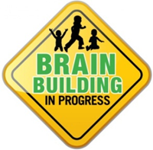

For more information about this or our many other programs, please

visit our website at www.miltonearlychildhoodalliance.org or…

MECA is funded through a grant from the Mass. Department of Early Education and Care and is administered by Discovery Schoolhouse, Inc.
We gratefully acknowledge the First Congregational Church for their generous support of our office space.

